Semester One Examination, 2017

Question/Answer booklet

MATHEMATICS

SOLUTIONS
METHODS
UNIT 1

Section Two:

Calculator-assumed

Student Number: In figures

In words

Your name

Time allowed for this section
Reading time before commencing work: ten minutes
Working time: one hundred minutes

Materials required/recommended for this section
To be provided by the supervisor
This Question/Answer booklet
Formula sheet (retained from Section One)

To be provided by the candidate
Standard items: pens (blue/black preferred), pencils (including coloured), sharpener, correction fluid/tape, eraser, ruler, highlighters

Special items: drawing instruments, templates, notes on two unfolded sheets of A4 paper, and up to three calculators approved for use in this examination

Important note to candidates
No other items may be taken into the examination room. It is your responsibility to ensure that you do not have any unauthorised material. If you have any unauthorised material with you, hand it to the supervisor before reading any further.

Structure of this paper

Section | Number of questions available | Number of questions to be answered | Working  time (minutes) | Marks available | Percentage of examination
Section One:  Calculator-free | 7 | 7 | 50 | 52 | 35
Section Two:  Calculator-assumed | 11 | 11 | 100 | 85 | 65
 |  |  |  | Total | 100

Instructions to candidates

1. The rules for the conduct of examinations are detailed in the school handbook. Sitting this examination implies that you agree to abide by these rules.

2. Write your answers in this Question/Answer booklet.

3. You must be careful to confine your response to the specific question asked and to follow any instructions that are specified to a particular question.

4. Additional working space pages at the end of this Question/Answer booklet are for planning or continuing an answer. If you use these pages, indicate at the original answer, the page number it is planned/continued on and write the question number being planned/continued on the additional working space page.

5. Show all your working clearly. Your working should be in sufficient detail to allow your answers to be checked readily and for marks to be awarded for reasoning. Incorrect answers given without supporting reasoning cannot be allocated any marks. For any question or part question worth more than two marks, valid working or justification is required to receive full marks. If you repeat any question, ensure that you cancel the answer you do not wish to have marked.

6. It is recommended that you do not use pencil, except in diagrams.

7. The Formula sheet is not to be handed in with your Question/Answer booklet.

Section Two: Calculator-assumed 65% (85 Marks)
This section has eleven (11) questions. Answer all questions. Write your answers in the spaces provided.

Working time: 100 minutes.

Question 8 (6 marks)
(a) The variables $C$ and $n$ are directly proportional to each other, so that when $n=10$, it is known that $C=25$. Sketch a graph of the relationship between $C$ and $n$ on the axes below. (3 marks)

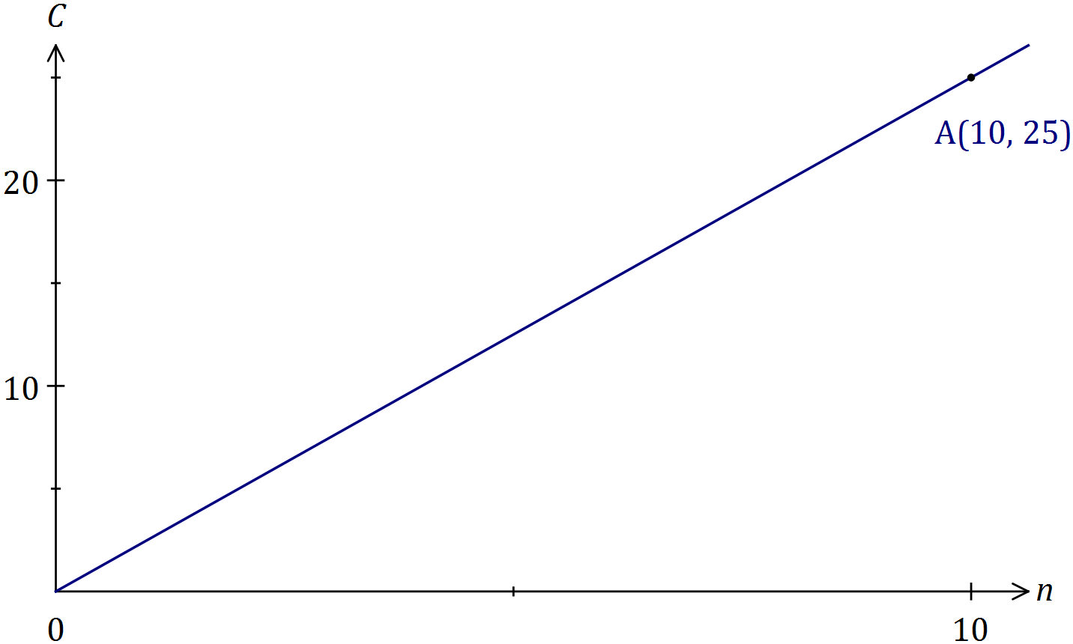
Solution
See graph
Specific behaviours
scales added to both axes
straight line through origin using ruler
indicates passes through (10, 25)

(b) The variables $A$ and $n$ are inversely proportional to each other, so that when $n=10$, it is known that $A=60$.

(i) Write an equation that relates $A$ and $n$. (2 marks)
Solution
$$A∝\frac{1}{n}⇒A=\frac{k}{n}$$
$$k=10×60=600⇒A=\frac{600}{n}$$

Specific behaviours
correct form of equation
determines constant

(ii) Determine the value of $n$ when $A=15$. (1 mark)
Solution
$$n=\frac{600}{15}=40$$

Specific behaviours
states value

Question 9 (5 marks)

(a) The volume (V) in litres (L) of a gas, at a fixed temperature and of a certain mass, varies inversely to the pressure (P) in Pascals (Pa).

(i) Find k, the constant of proportionality, given that when P = 11.5 Pa and V = 2.84 L.
(2 marks)

Solution
(i) 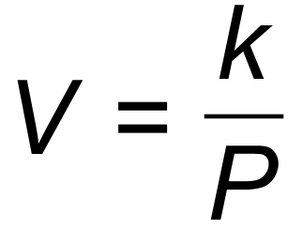
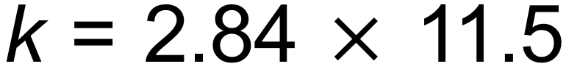
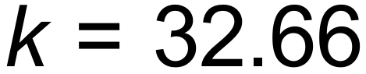

Specific behaviours
states equation
determines constant

(ii) Describe the effect on V when P is halved. (1 mark)

Solution
The volume doubles.
Specific behaviours
states double

(b) Jan is a real estate agent who earns a commission of 3.25% on the sale of a house. If $c is the commission and $s is the sale price of a house, show clearly c is directly proportional to s. (2 marks)

Solution
is a linear relationship in the form 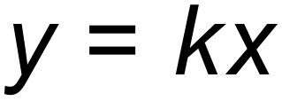 where
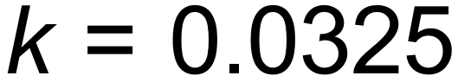 and is therefore directly proportional.
Specific behaviours
states equation
shows constant for direct proportion

Question 10 (5 marks)

The reciprocal function 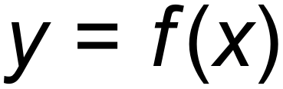 shown below has asymptotes at 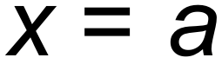 and 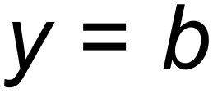.
The y-intercept is at (0, c).

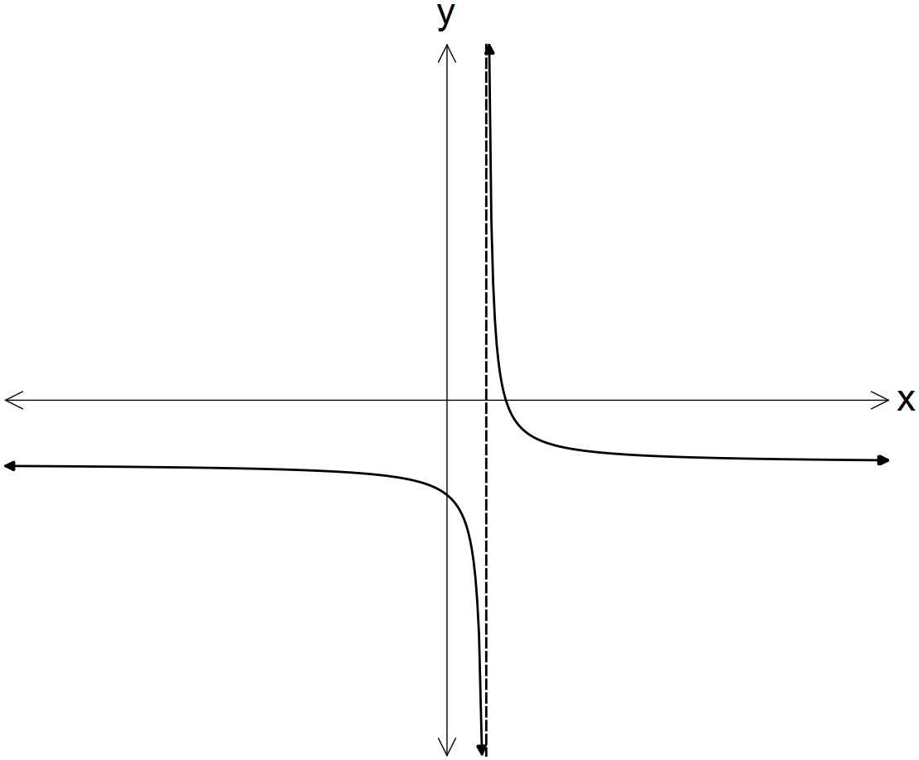

In terms of a, b and/or c:

(a) determine the equation of the horizontal asymptote for 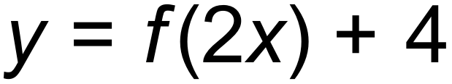. (1 mark)

Solution
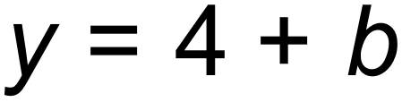
Specific behaviours
states correct answer

(b) determine the coordinates of the y-intercept of 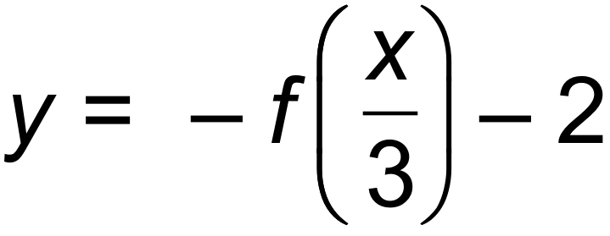. (2 marks)

Solution
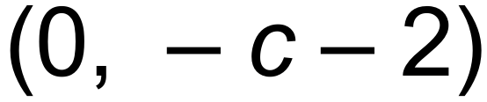
Specific behaviours
determines y value
gives as coordinates

(c) state the domain of the function 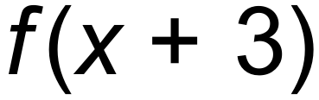. (2 marks)

Solution
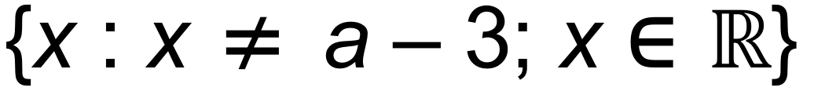
Specific behaviours
vertical asymptote moves 3 to left
states domain

Question 11 (11 marks)

Consider the functions graphed below.
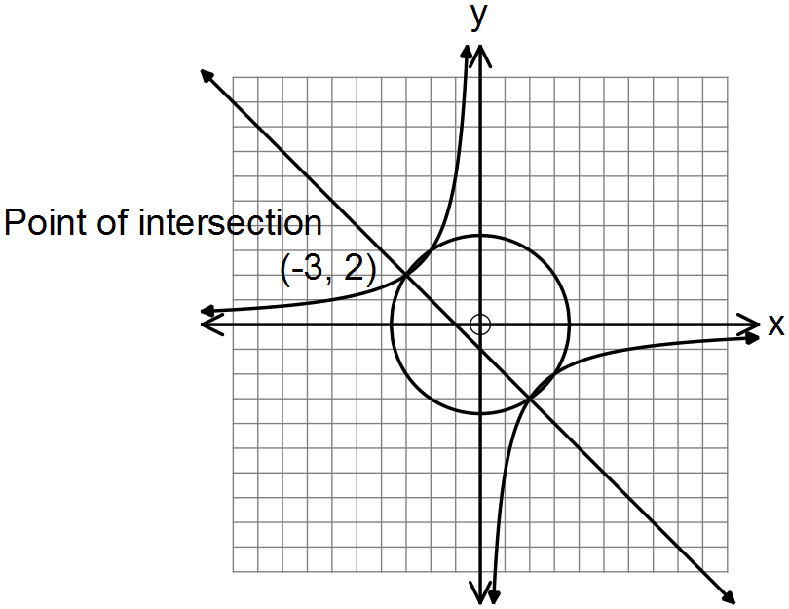

(a) State the equation for:

(i) 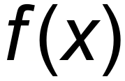, the circle with centre at the origin. (2 marks)

Solution
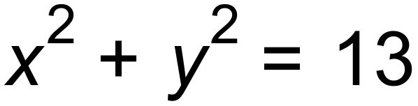
Specific behaviours
uses squared terms
uses correct radius

(ii) 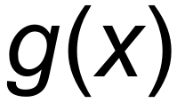, the hyperbola. (2 marks)

Solution
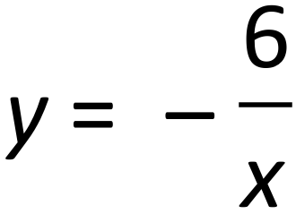
Specific behaviours
uses correct format
use correct constant

(iii) 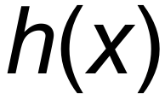, the straight line. (2 marks)

Solution
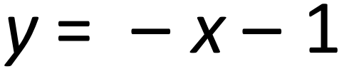
Specific behaviours
correct gradient
correct constant

(b) Hence, solve the equation 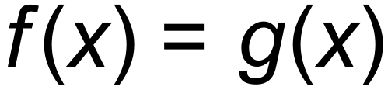. There are four solutions. (2 marks)

Solution
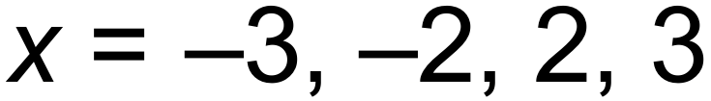
Specific behaviours
states two correct solns
states four correct solns

(c) The graph  undergoes the following transformation 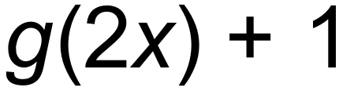.

(i) State the coordinates of the point (–3, 2) after this transformation has occurred.
(2 marks)
Solution
(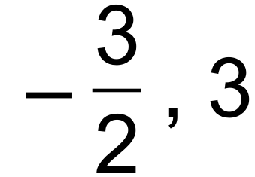)
Specific behaviours
correct x
correct y

(ii) The graph  undergoes the same transformation namely 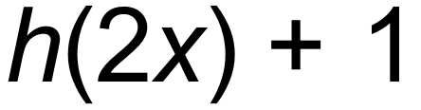. State the gradient of the transformed function. (1 mark)
Solution
m = 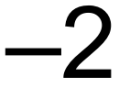
Specific behaviours
states correct value

Question 12 (7 marks)

(a) Consider the following sets of ordered pairs:
f = { (1,2), (2, 3), (3,4) } h = { ( 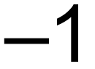, 4), (0, 3), (1,2) }

(i) Find f (2). (1 mark)

Solution
3
Specific behaviours
states correct value

(ii) Find a such that h (a) = 3. (1 mark)

Solution
0
Specific behaviours
correct value

(iii) Find t such that f (t) = h (t). (1 mark)

Solution
1
Specific behaviours
correct value

(b) Compare the domain of 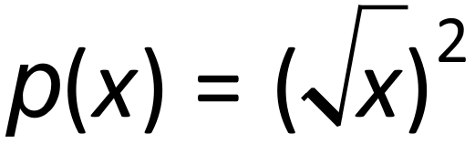 and 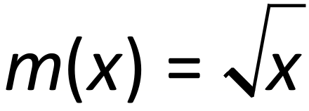. (2 marks)

Solution
Domain of 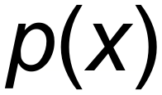 is the same as 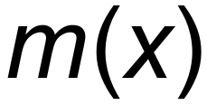. For both: 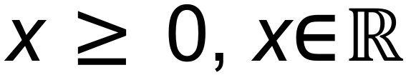
Specific behaviours
states the same
shows x greater than or equal to zero

(c) The function, 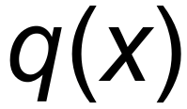 below, is a transformation of 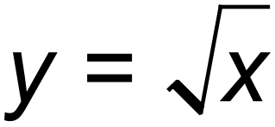.
State the equation of the function, 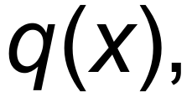 below. (2 marks)

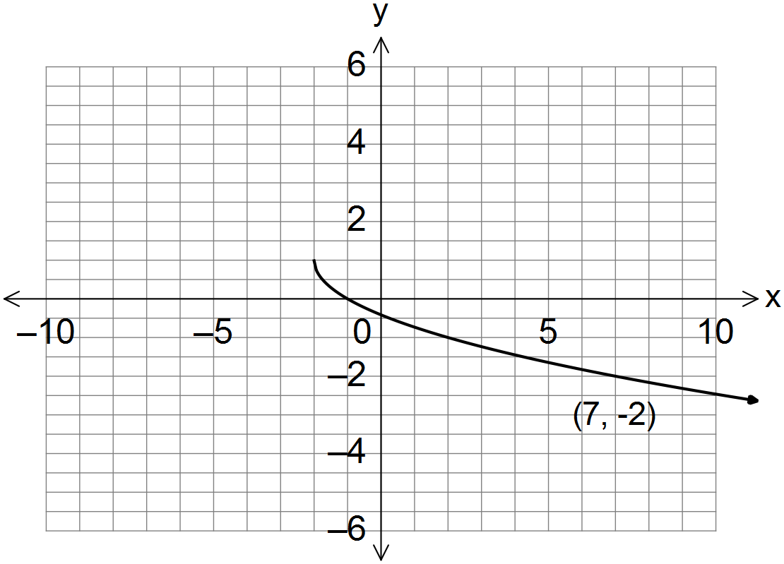

___________________________

Solution
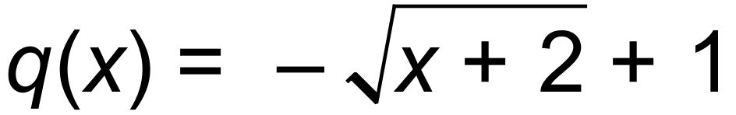
Specific behaviours
uses negative sign in front of square root
correct function

Question 13 (6 marks)

The following functions are shown below:
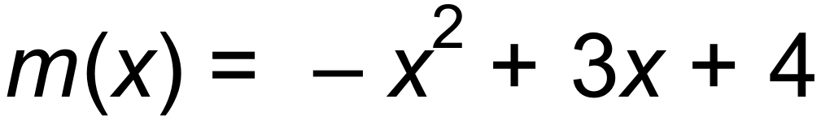 and 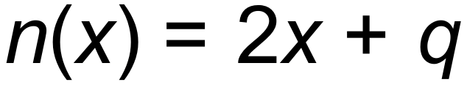, where q is a constant.
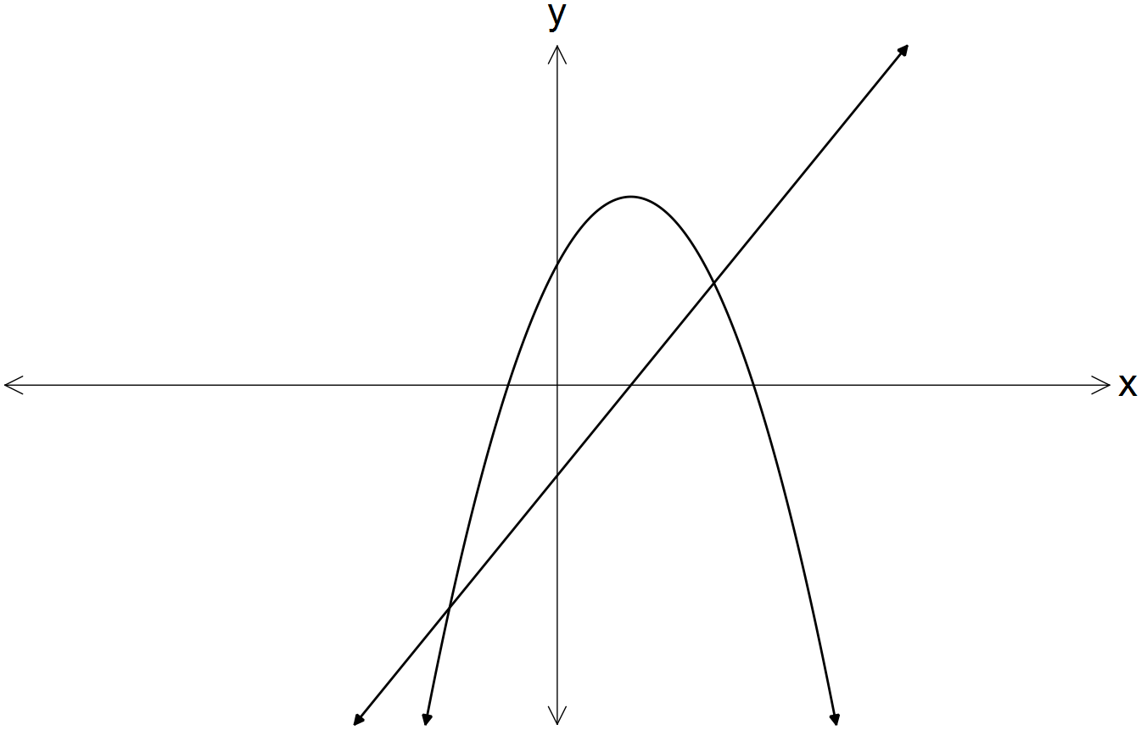

For what value(s) of q does the equation 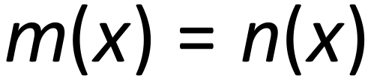 produce:

(a) one solution? (4 marks)

Solution
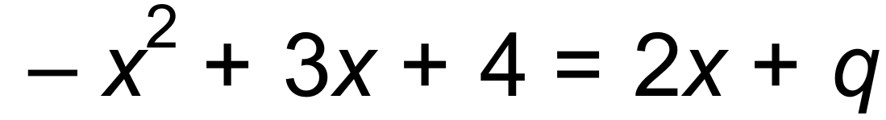
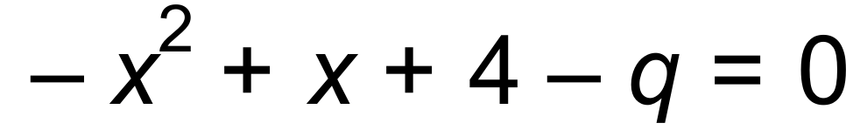
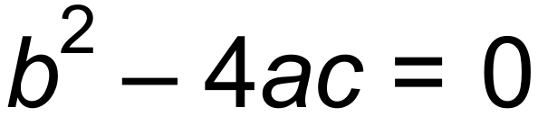 for one solution
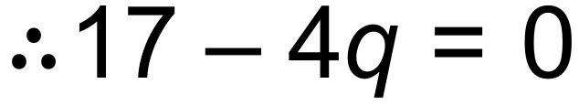
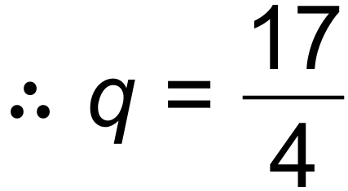
Specific behaviours
equates y values
determines discriminant of quadratic equation
equates to zero
solves for q

(b) no real solutions? (2 marks)

Solution
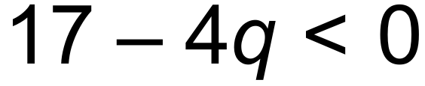
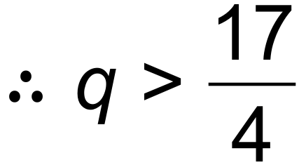
Specific behaviours
states discriminant is less than zero
solves inequality

Question 14 (8 marks)
(a) The graph of $y=2x^{2}+bx+16$ has a line of symmetry with equation $x=3$.

(i) Determine the value of $b$. (2 marks)
Solution
$$x=-\frac{b}{2a}⇒b=-3×2×2=-12$$

Specific behaviours
uses line of symmetry
value of $b$

(ii) Draw the graph of the parabola on the axes below. (3 marks)

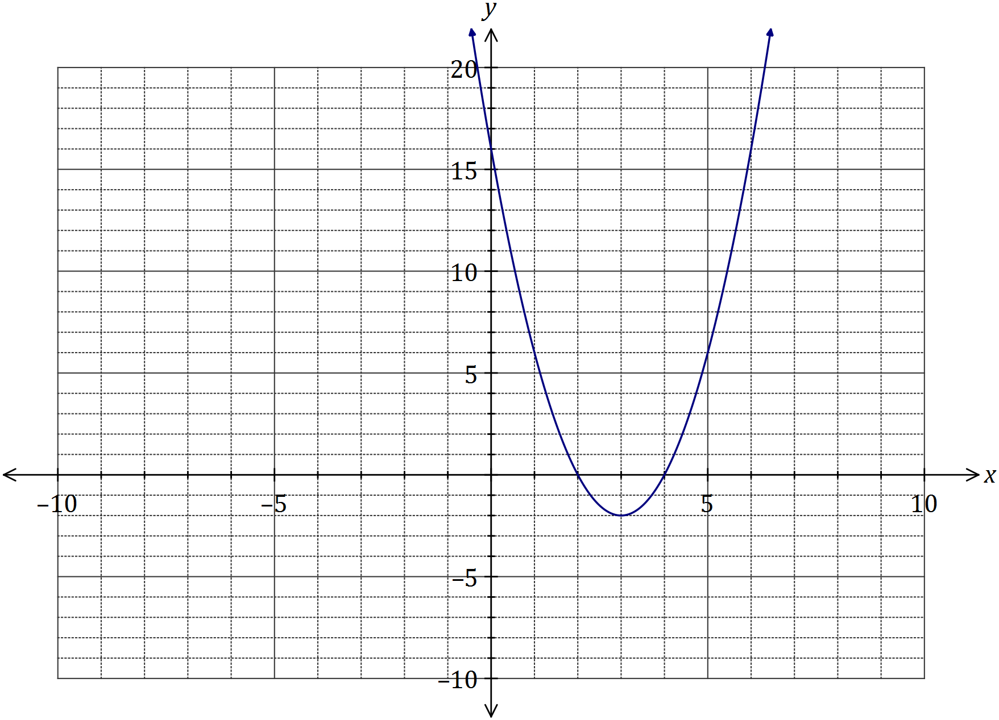
Solution
See graph
Specific behaviours
turning point
three axes intercepts
smooth curve

(b) One of the solutions to the equation $2x^{3}+21x^{2}+cx-495=0$ is $x=5$. Determine the value of $c$ and all other solutions. (3 marks)
Solution
Using CAS, when $x=5, 5c+280=0⇒c=-56$
Use CAS to solve $2x^{3}+21x^{2}-56x-495=0$
$$x=-11,x=-4.5 \text{and} x=5$$

Specific behaviours
substitutes $x=5$
determines $c$
states other two solutions

Question 15 (5 marks)

(a) State the centre, C, and the radius, r, of the circle given by .
(2 marks)

Solution
Centre (3,5) radius 6
Specific behaviours
states centre
states radius

(b) Write a possible equation, in terms of a, b and/or c, which are positive constants, for each graph shown below.
(3 marks)
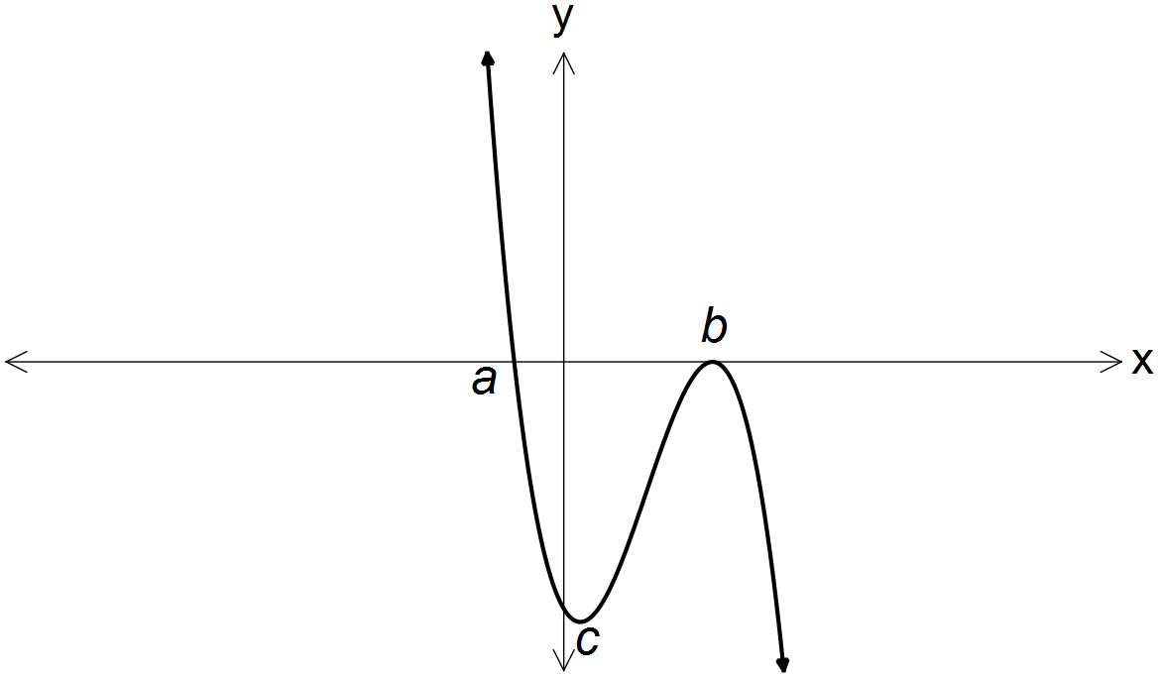 (i)

_________________________

Solution
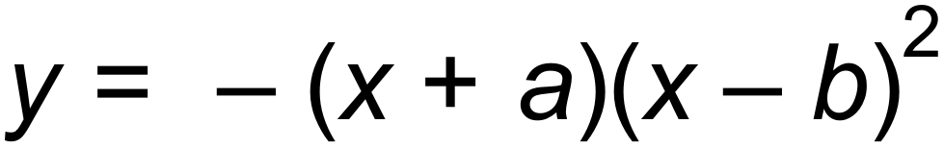
Specific behaviours
correct expression

(ii)
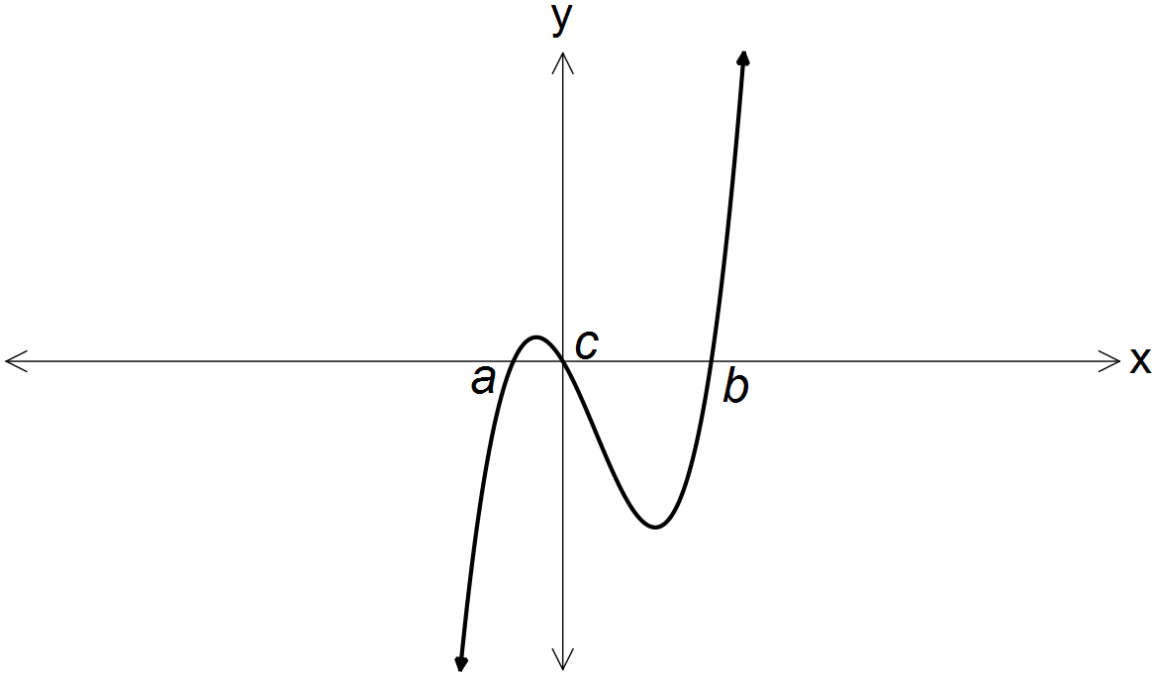

_________________________

Solution
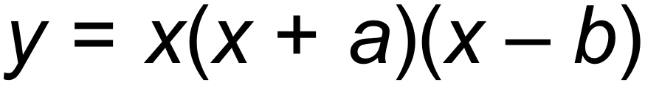
Specific behaviours
correct expression

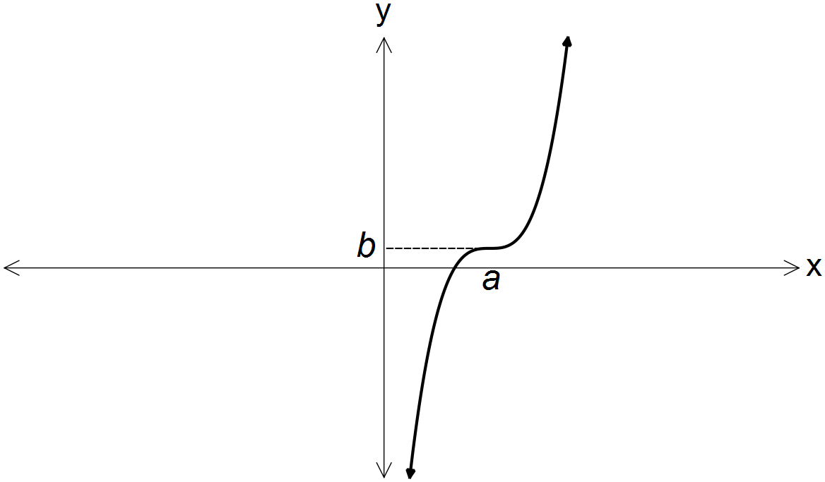

(iii)

_________________________
Solution
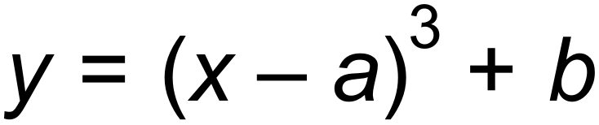
Specific behaviours
correct expression

Question 16 (8 marks)
The graph of the function is defined by $f\left(x\right)=$ $\frac{a}{x+b}$ is shown below.

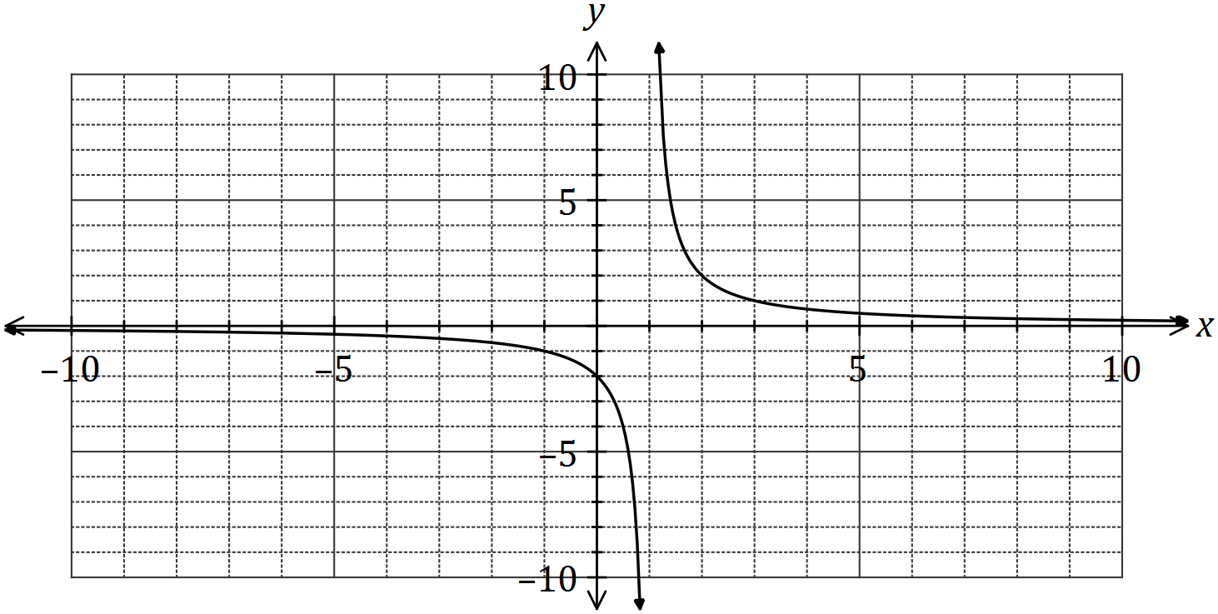

(a) Determine the values of $a$ and $b$. (2 marks)
Solution
Using vertical asymptote, $b=-1$
Using $y$-intercept, $a=2$

Specific behaviours
value of $a$, value of $b$

(b) State the domain and range of $f\left(x\right)$. (2 marks)
Solution
$$D_{f}=\left\{x:x∈R, x≠1\right\}$$
$$R_{f}=\{y:y∈R, y≠0\}$$

Specific behaviours
indicates $x≠1$, indicates $y≠0$

(c) Determine the equations of the asymptotes of the graph of $y=f(2x)$. (2 marks)
Solution
Vertical asymptote: $x=\frac{1}{2}$, horizontal asymptote: $y=0$

Specific behaviours
vertical asymptote, horizontal asymptote.

(d) Describe the transformation required on the graph of $y=f(x)$ to obtain the graph of

(i) $y=f(x+8)$. (1 mark)
Solution
Translate 8 units to the left.

Specific behaviours
description

(ii) $y=\frac{1}{2}f(x)$. (1 mark)
Solution
Dilate vertically by scale factor $\frac{1}{2}$

Specific behaviours
description

Question 17 (8 marks)

Let

- Sketch the function on the axes below. (6 marks)

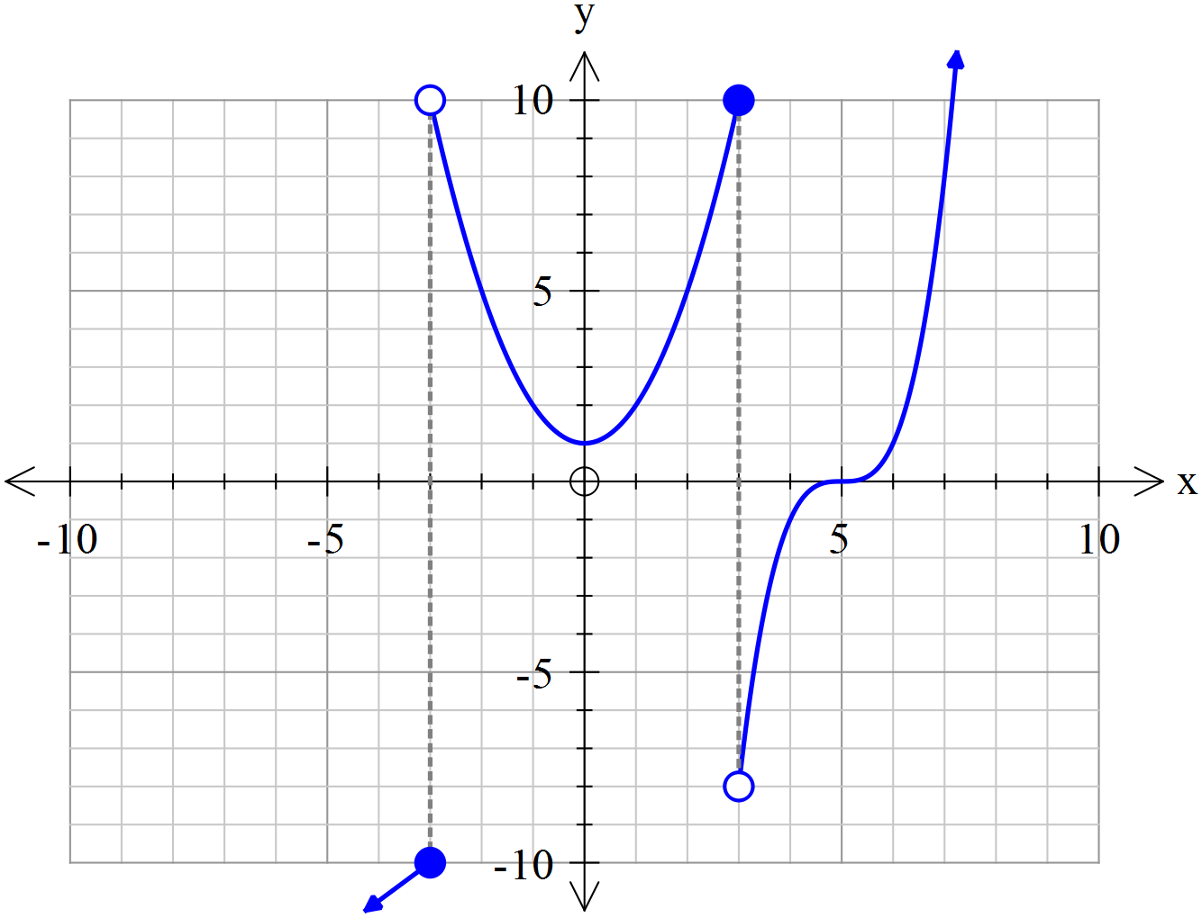

Solution
Specific behaviours
correct circle shaded for x=-3
correct circle shaded fpr x=3
y intercept shown
x intercept shown
correct shape of function at x-3
all sections have correct shape

- State the maximal(natural) domain and range. (2marks)

Solution
Domain R
Range or
Specific behaviours
correct domain
correct range

Question 18 (8 marks)

- A quantity z varies partly as directly proportional to x squared plus directly proportional to y cubed. For x=7 and y=11, z = 4189. For x=12 and y=5, z=951. Determine the value of z for x=9 and y=15. (4 marks)

Solution
Specific behaviours
writes equation for z in terms of two constants
sets up two equations with constants
solves both constants
determines final value of z

- If determine the percentage change in w if x decreases by 30% and y increases by 20%. (4 marks)

Solution
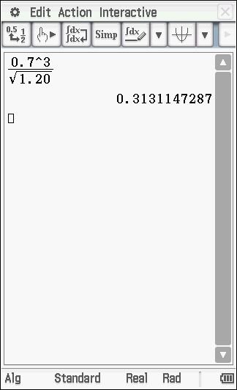
Specific behaviours
uses 0.7 for x
uses 1.20 for y
subs into equation for w
states a decrease of 69%

Question 19 (6 marks)

- Determine the quotient and remainder when is divided by (4 marks)

Solution
Specific behaviours
uses long division method
determines squared term of quotient
determines complete quotient and states this as the quotient
determines and labels remainder

- Determine the value of the constant so that is a factor of (2 marks)

Solution
Specific behaviours
sets up equation with constant
solves for constant

© 2016 WA Exam Papers. Rossmoyne Senior High School has a non-exclusive licence to copy and communicate this paper for non-commercial, educational use within the school. No other copying, communication or use is permitted without the express written permission of WA Exam Papers. SN085-092-4.

